# A First Play

Power up the Noodlebox by plugging in the power supply and holding the ON button for 2-3 seconds.

Turn it off again by pushing the OFF button. This is the correct way to shut down the Noodlebox; it makes sure that any changes you have made to the configuration are saved. If you just pull the plug you will lose these changes.

When you power up Noodlebox with a new session, you will see a screen like this. We call this a **page**

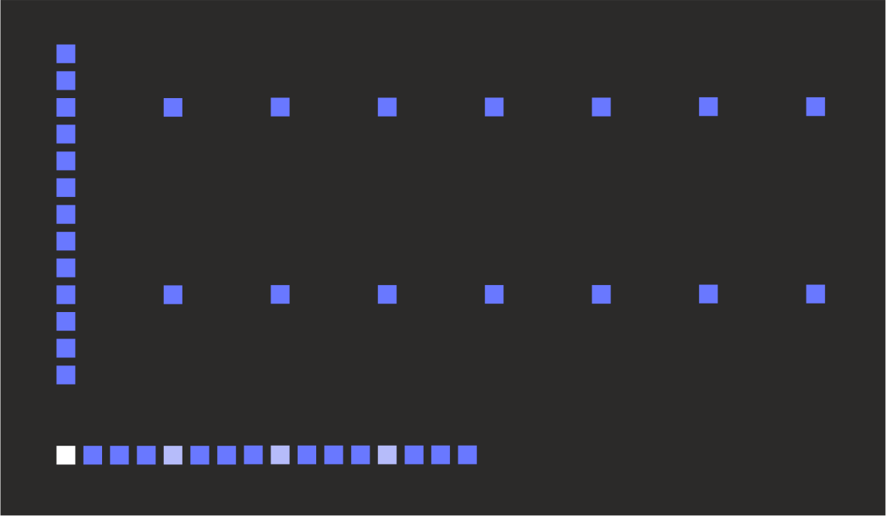

The page has 32 columns and 16 rows. Each column represents a single **step** in a musical pattern which can contain up to 32 steps. You can always see all 32 steps on the page at the same time

The line of dots along the bottom row defines the **loop window**. While the page has 32 steps, fewer than this number may be active for being played. When we start a session, the default loop window is the first 16 steps, however the loop window can be set to any number of continuous steps and can play in either direction.

The line of dots that indicates the loop window is called the **loop ruler**. The active step (the one which is playing) is indicated on the loop ruler in full brightness. Initially this is the first step. Every fourth step along the ruler is indicated in medium brightness.

The vertical bar at the left margin of the display is the **cursor**, which we use for the various editing functions. The cursor can be moved from left to right by turning the encoder knob.

The top 13 rows of the display (the height of the cursor) is where we enter the value for each step. The two horizontal dotted lines that are already there are part of a grid showing the “C” notes at the start of each octave. These are to help you find your way around!

So let’s enter a note… move the cursor into the middle of the loop window, hold down the CV button and turn the encoder. A bright point appears along the cursor (this is the note we added) together with a text box showing the name of the note (e.g. “A2” – the A note in octave 2). By keeping the CV button pressed and turning the encoder we can set the note to any pitch we like (see how the screen scrolls up and down).

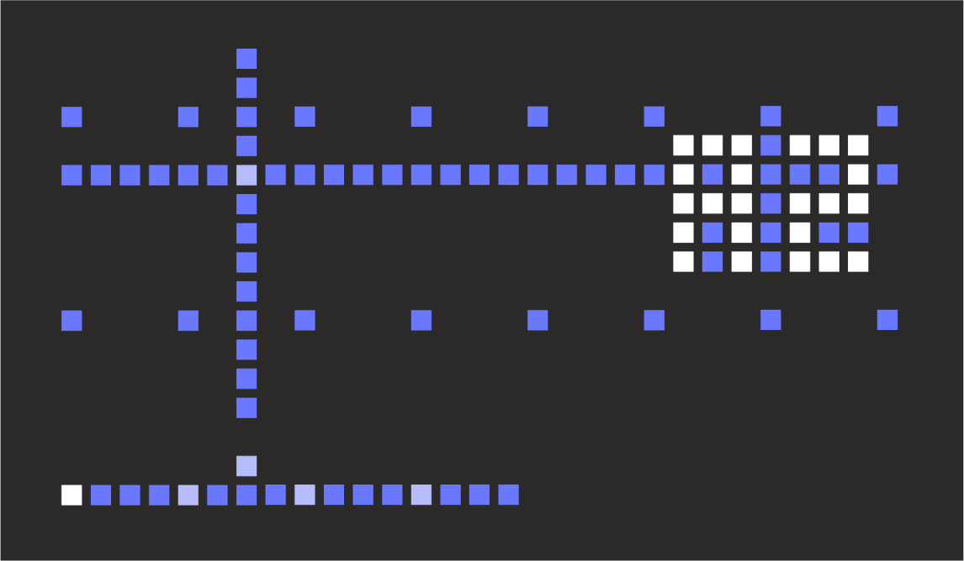

When we release the CV button, the note has been set. A new point has also been added at the bottom of the screen – this is a trigger point, which indicates we’ll send a gate pulse to the gate output.

We also now have a horizontal line spanning the whole display. This represents the control voltage (CV) output. Since we have only one note defined, the CV output will send the pitch CV for this note continuously (Pitch CV never “turns off”, it must always be set to something!)

Now add another point… move the cursor to a new position and hold CV and turn the encoder. Initially the note picks up the CV value in that column and we can then drag it around (The very first note that we add to a blank page will default to note C2)

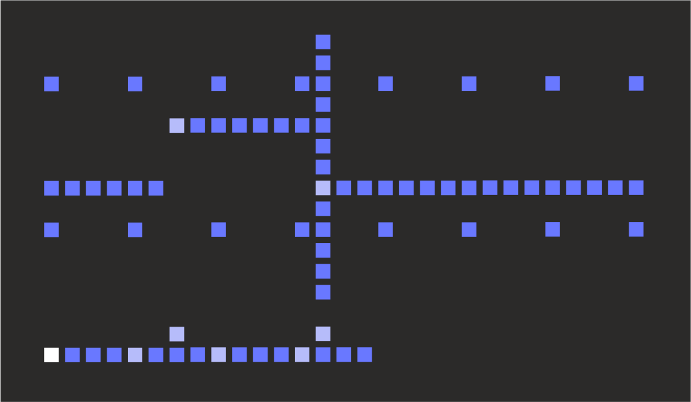

So here we have a sequence of A2 and E1. There are two trigger points and the pitch CV always follows the last note value we entered. These values are shown in a brighter colour to show that they are **data points** we created ourselves, where the other points are dimmer to show they are **fill points**. We’ll use these names going forward, since these points are not always note pitches (they can be modulation voltages etc.)

Now lets play this sequence… press the RUN button (above the encoder). Now we see the active step marker count along the loop window bar (and return back to the start when it reaches the end). The current data or fill point and trigger point (if any) are also shown in the brighter colour.

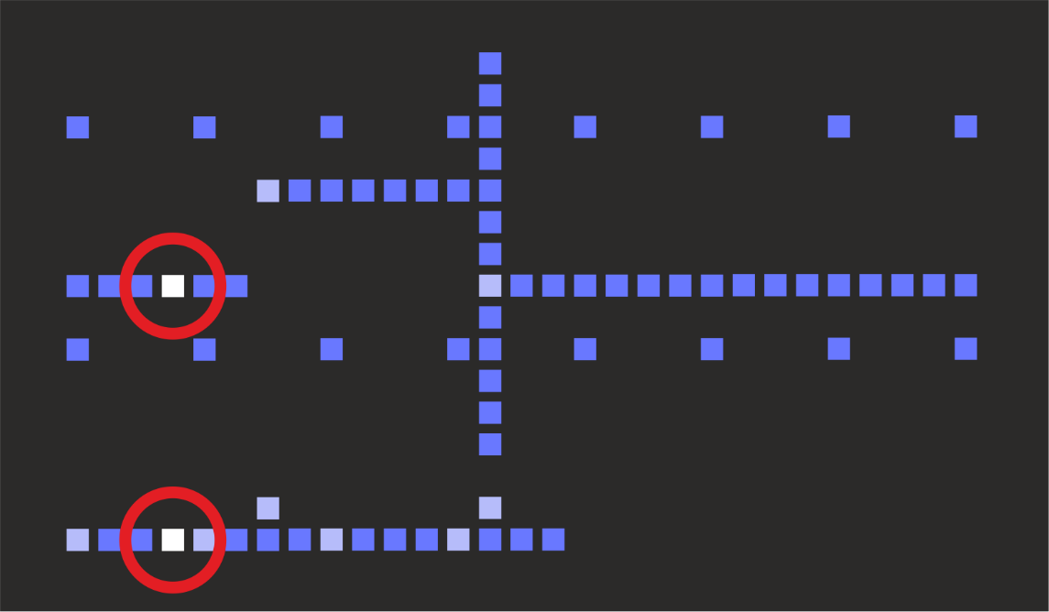

Patch up GATE 1 and CV A to your synth to hear it play! If you want to use the MIDI output, click the LAYER button to show the menu. Use the encoder to scroll down to the entry MID NONE and hold the CV button while turning the encoder to select MID NOTE. Now change the MIDI channel if needed. Press the LAYER button to return to the main display.

# General Operation

Noodlebox packs a lot of functionality behind just 11 buttons and an encoder knob… We’ve tried to avoid too much menu diving but there are some special moves it will definitely help to know when using it…

* When we say **click** a button we mean you just press and release it, without changing anything else
* When we say **hold** a button we mean you keep it pressed down while doing something else, such as clicking another button or turning the encoder knob
* In some situations, the first four buttons (CV, GATE, CLONE, CLEAR) double up as **number keys 1, 2, 3, 4**. For example you can select layer 3 by holding LAYER and then clicking CLONE(3) and you can select page 2 by holding PAGE and clicking GATE(2)
* A lot of the ‘deeper’ Noodlebox functions use a **double button hold** along with a turn of the encoder knob. This means that two buttons are held down together and the order of button pressing is important. For example, holding GATE then holding LOOP and turning the encoder adjusts gate retriggering. We’d mark this in the instructions as “hold GATE+LOOP”. The order is important - *holding* *GATE+LOOP is not the same as holding LOOP and pressing GATE… that would be LOOP+GATE! Got it?*

As much as possible we’ve tried to keep the basic labels of each button meaningful for combinations. For example CLEAR+PAGE clears pages, GATE+RAND sets gate randomness. However this is not always possible and some combinations might be harder to remember.

Learning these combinations might be a bit of a challenge, but we decided to go this way rather than menu diving, and we’ve tried to keep the most common functions accessible without needing combination of buttons. Hope that’s OK :)

* Above the encoder is the FN button. This is an additional shift key and is mostly used in conjunction with the eight main buttons to **toggle settings** (such as automatic gates or record arm).
* OK - cards on the table - there are **menus**; two of them. They are only one level deep though and we tried to keep them short and easy to whizz through in a live situation. The layer menu is accessed by clicking LAYER. The global menu is accessed by holding FN and clicking LAYER.

When a menu is open, use the encoder to **select the menu option**, then hold the CV button and use the encoder to **change the value** of the option. Menu settings are not applied until you release the CV button (or press another button)

# Creating and Adjusting Data Points

Before the first data point is added to a page, the CV value at every step is zero

To create a data point use the encoder to move to a column and hold the CV button. Move the encoder with CV pressed to enter the data point.

The *very first* data point to be create on a page in a **pitch** layer starts at a default value of C2. In **modulation** and **offset** layers the default value of the first data point is zero.

After the first data point is set, all the other steps in the page take on a value which depends on the **fill mode** (which can be changed by pressing FN + CLONE)

* **PAD** – after a data point is set, all the following steps take on the same value, until a step is reached which has another data point set at a different value. The value of the new data point is filled out into subsequent steps. This is the default behaviour for pitch and offset layers.
* **INT** (Interpolated) – Works like PAD if there is only one data point. With two or more data points, the fill points are calculated along the straight (possibly sloping) line between each pair of data points. This is the default behaviour for modulation layers.
* **OFF** – all steps have a zero value unless a data point has been created there

Now when you create data points in new columns, they pick up the initial value of the step and you can move them up and down by holding CV and turning the encoder. You can change the value of existing data points in exactly the same way.

# Automatic Creation of Gate Points

In a pitch layer, a new gate point is usually **created automatically** each time a new data point is created. This is useful when entering notes, as typically you would want to trigger an envelope on your synth with each change of note. Noodlebox also needs the gate point to determine where a new MIDI note begins.

Gate points in **modulation** and **offset** layers are usually be created manually (Editing of gate points will be described in a later section)

You can use the **auto gate** setting (FN + GATE) to decide, for a given layer, whether new gates will be automatically created with data points, overriding the default behaviour described above.

* **AUT** (Auto)means that a new gate point will be created when a **new** data point is inserted (not for adjusting an existing one) . Pitch layers have this mode by default.
* **MAN** (Manual) means you must add gate points manually. Modulation and offset layers have this mode by default

Gate information can be edited or deleted manually in either mode. Gate editing is described fully later on.

# About Data Point Values

Each data point can have a value between 0 and 127. Depending on the layer mode, this range of values can be shown as

* In **pitch** mode the values are displayed as *note names*, from C-1 (0) to G9 (127). These names are made up of the note (A, A#, B, C, C#, D, D#, E, F, F#, G, G#) and the octave number (-1, 0, 1, 2, 3, 4, 5, 6, 7, 8, 9)
* In **modulation** mode the values are shown directly (000 to 127)
* In **offset** mode the ‘internal’ values 0-127 are mapped to offset values between -64 (0) and +63 (127).

Values are preserved for existing data points when you change the type of a layer. For example, if you create a data point on page in an offset layer with a value of +00 then switch the layer type to modulation, you’ll see the value 64. If you switch to pitch you’ll see the note E4.

# Fine Adjustment of Data Points

When you edit the value of a data point, you always move the point up and down one display row at a time. However, this might not always mean you are changing the value by 1 unit…

* In **pitch** mode it depends on the *rows layout* setting which can be **scale** or **chromatic** (FN + CV to change it). In rows layout of chromatic, each display row maps to one unit and there are 11 rows to an octave. However, in rows layout of scale, there are only 7 rows to an octave - 4 notes (those which are ‘out of key’) cannot be accessed in the usual way.
* In **modulation** mode each row covers 10 units, so the entire range 0-127 will fit within 13 rows of the display without scrolling. Moving a value by a single row makes it jump by up to 10 units at a time.
* In **offset** mode there is always 1 unit per row

To be able to select the ‘skipped’ values you can **fine adjust** the data point by holding down the GATE button in addition to the CV button while turning the encoder.

# Clearing Data Points

To **clear a single data point**, click the CLEAR button. A single click on CLEAR will remove the data point, and any corresponding gate information.

To **clear multiple data points** and corresponding gate information, hold the CLEAR button down and move the encoder knob to the left and/or right.

These actions will clear the data points and any gate information at the same step positions. As the data points are removed, fill points on the page will be recalculated as needed.

* It is possible to clear single or multiple data points *without clearing gate information* by pressing the CV button while CLEAR is held
* Conversely, it is possible to clear the gate information on single or multiple data steps *without clearing data points* by pressing the GATE button while CLEAR is held

# Cloning Data Points

An **existing step** (both step value and gate information), can be cloned into one or more adjacent target steps by selecting it with the cursor, then holding the CLONE button and turning the encoder knob left or right. The data point and gate information are copied into the new cursor locations, replacing any existing content.

A **continuous range of steps** (value and gate information) can be cloned by first setting the **source position** by pressing and releasing the CLONE button. The marker (a bright pixel) appears below the bottom of the cursor. The cursor can then be moved to the **target position** (which may be on a different page or even in a different layer). Press CLONE again and move the encoder left or right to copy data from the source position to the target position (replacing any existing content). The source marker will move left and right in step with the cursor movement. Once CLONE is released, the action is finished. Once the source position is set, pressing any button except CLONE, PAGE+(page) or LAYER+(layer) will cancel the action.

These actions will copy both data points and any gate information at the same step positions. As the data points are removed, fill points on the page will be recalculated as needed. If you copy a fill point, a new data point will be created if needed to preserve the copied value.

* Clone single or multiple data points *without affecting gate information* by pressing the CV button while CLONE is held at the target step location.
* Clone gate information on single or multiple data steps *without affecting data points* by pressing the GATE button while CLONE is held at the target step location.

If you have set the clone source position and want to cancel the action, simple click CLONE again.

# Shifting Data Points

The entire page of data points can be shifted around vertically (i.e. in pitch) or horizontally (i.e. in time)

* While holding CV, hold RAND and use the encoder to **move all data points up or down**. Initially the display shows VERT then the offset from the original position. With ROWS: SCA set (FN + CV) in pitch mode, the points increment to the next or previous note in scale.
* While holding CV, hold CLEAR and use the encoder to **move all data points left or right**. Initially the display shows HORZ then the offset from the original position. You can shift up to 32 steps in either direction (data wraps around, so +/-32 steps is equal to the start position)

The loop window does not move during this operation, so it is a useful creative technique to set a small loop window and shift data points into and out of it.

# Gate Information

As well as a data point, each step has **gate** information associated with it. This says whether the gate output socket associated with the layer will be set OFF or ON (10V) when the step plays. There are two settings at each step that control the gate output.

* **Trigger** (trig) – at a step that has a trig enabled, the gate output for the layer will always switch from OFF to ON when that step plays. It is the OFF->ON transition that triggers the envelope in a synth.

If the gate output was already ON, a trig point will cause it to switch ON->OFF->ON so that there is still an OFF->ON transition at the start of the step.

The gate output remains ON for the proportion of the step time defined by the DUR setting (gate duration) in the Layer menu.

* **Tie** – at a step that has tie enabled, the gate output for the layer will be ON for the whole duration of the step. If the gate output as ON at the start of the step then there is no OFF->ON transition *unless* trig is also enabled for the step. Ties can therefore be used to keep the gate open (ON) for time durations longer than a step.

Gate information is shown on the second to bottom row of the screen. Trigs are shown in medium brightness level and ties in dim level. The combination of a trig and tie is shown in full brightness.

Here is an example of the gate information at a sequence of steps, and the gate output that would result (assuming DUR is set at half a step)

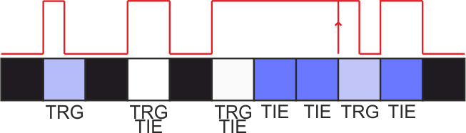

The main things to notice are that

* Every step that has **trig** set will begin with an OFF-ON transition
* If **tie** is set, the gate output is ON for the entire step duration.
* If **trig** is set without tie, the gate remains open based on DUR setting

A **tie** point will still cause an OFF-ON transition if the gate was previously OFF

Ties affect MIDI note output from a layer in a similar way; MIDI note duration is extended according to gate state, and changes to the note pitch while the gate is open will result in legato play (i.e. the MIDI note off message for an old note is sent after the note on message for a new note)

Tie points can also be used to selectively “glide” or slew CV between different values, based on the **slew** setting for the layer. In this case the voltage will glide between the previous step output and the new one. This glide will take place over the full step duration of the current step, with the step CV only being reached at the end of the step.

# Editing Trigs and Ties

Gate information may be edited separately from CV information in all layer modes.

Clicking the GATE button while the cursor is on a step toggles the **trig** setting of that step.

Holding GATE while turning the encoder modifies the **tie** setting. Turning the encoder one click in a clockwise direction enables tie. Turning the encoder in an anti-clockwise direction disables tie.

A tie can be extended over multiple steps by holding GATE and keeping turning the encoder clockwise. After tie is set at the first step, the cursor will move to the right and tie can be set at the following step. This can be continued until the end of the page is reached.

This process also works in reverse to clear ties from multiple steps. Start by placing the cursor on the right-most tie that you want to clear, then hold GATE and keep turning the encoder to the left until all the required ties have been cleared or the left side of the screen is reached.

# Additional Gate Settings

As well as trig and tie, the following gate settings can be made per step

* **Probability** – an element of chance can be attached to a gate point, which allows the data point and gate information for a stepto be ignored.

To set the probability for a gate, hold GATE and press RAND. While held, all gate points with nonzero probability settings are shown in a bright colour. Continuing to hold the keys while turning the encoder sets the probability for the selected gate point.

Probability can be set to 0 (always play) or to a number between 1-15 where 1 is least likely to play (on average 1 time out of 16) and 15 is most likely (average 15 times out of 16).

* **Retrig** – a gate or tie point can be set to retrigger multiple times during the duration of a single step. Retrig can be set from 0 for no retrigger, or to a number 1-15. This number is based on the sixteenth fraction of the full step period. The following diagram shows the number and distribution of retriggers during a single step period. After each retrigger, the gate stays open according to the duration setting



To set the retrig for a gate press GATE + LOOP. All gate points with nonzero retrig settings are shown in a bright colour. Continuing to hold these keys while turning the encoder sets the retrig for the selected gate point.

* **Accent** **–** each gate point has an **accent** setting which can be set to ON or OFF. This is mainly useful when a pitch layer is sending out MIDI notes. In this case the MIDI velocity for accented notes is taken from the ACC setting in the layer menu, rather than the usual VEL setting. This allows you to make certain notes louder (or softer) and vary their velocity independently of the other notes.

A second use for **accent** is to set an accent gate output which could be used to control the voicing of specific steps on your synth. An accent gate can be set on the SYNC OUT and/or AUX OUT outputs. These will fire when an accented step is played on any layer and will remain ON for the entire step duration.

To set the accent for a step, hold down GATE and then CV. All steps with accent are shown in a bright colour. Turning the encoder knob with the buttons held will set accent ON for a step where turning the knob to the left will turn accent OFF.

# Playing a Sequence

To **start** playback, click the RUN button above the encoder knob. Click the RUN button again to **stop** playback. Pressing RUN again will **continue** playback from the current position.

To **restart** playback of all layers from their first steps, click CV + RUN. You can do this whether stopped or playing.

To immediately move the play position of the current layer to any step in the current page, click the LOOP button.

# Tempo and Clock Division

To change the tempo of playback, press the LAYER button to show the layer menu and scroll to the end of the menu to the BPM item. Hold CV and turn the encoder to change the BPM. The tempo changes when CV is released

Note that **the BPM option is only available when running from the internal clock**. Clocking options are described below.

As well as BPM, the playback of each layer is determined by its clock division (rate). This can be changed in the menu using the RAT option. The values are listed as musical note divisions from 1 (1 full note = 4 clock beats) to 32 (1/32 note = one eighth of a beat). The divisions are listed from largest (i.e. slowest count) to the smallest (i.e. fastest count). A typical setting is 16 (1/16 note = one quarter beat).

The full list of clock divisions in the RAT menu item are as follows

|  |  |
| --- | --- |
| 1 | Full note (4 beats) |
| 2D | Dotted half note |
| 2 | Half note |
| 4D | Dotted quarter note |
| 2T | Half note triplet |
| 4 | Quarter note (1 beat) |
| 8D | Dotted eighth note |
| 4T | Quarter note triplet |
| 8 | Eighth note |
| 16D | Dotted sixteenth note |
| 8T | Eighth note triplet |
| 16 | Sixteenth note (default) |
| 16T | Sixteenth note triplet |
| 32 | 32nd note |

# Clocking Options

In addition to being able to run from an internal BPM, Noodlebox allows various external clock sources to be used. The clock source is set from the CLK option in the global menu, which has the following possible values:

* **INT** – Internal clock, based on the BPM setting. When selected, the BPM option is shown in the layer menu. It is hidden otherwise.
* **MCLK** – External MIDI clock is used for BPM but transport (i.e. start, stop, reset) must be controlled from the front panel. MIDI transport message are ignored.
* **MTRN** – External MIDI clock and transport messages are accepted. Front panel transport functions (i.e. stop, start, reset) can also be used.
* **PCLK** –External pulse clock via SYNC IN socket. The expected clock rate is set via the **SYI** option

To keep Noodlebox in phase with the master clock, start the sequencer with the reset (CV + RUN) command while the external clock is already running

# Loop Window

The **loop window** defines the block of steps in the page that will play when the sequence is running. While there are always 32 steps in the page, the loop window can be anything from 1 to 32 steps in length. By default the loop window is 16 steps long.

The loop window is indicated on the bottom row of the screen by a continuous row of pixels of low brightness with every fourth step (starting from the loop start position) shown in medium brightness. This pattern of pixels is called the **loop ruler**.

To set the loop window, use the encoder to move the cursor to the new loop start position, then hold down the LOOP button and move the cursor to the new loop end position. The new loop window does not become effective until the LOOP button is released.

When the sequencer is running, playback counts from the loop start position to the loop end position, then jumps back to the loop start position again. The loop start position may be to the right of the end position, in which case the **playback will run in reverse**.

Usually each of the four layers has a single loop window set, which is shared between the four pages in the layer. This can be changed via the loop points setting (FN + LOOP)

* **LOOP:LAY:** All pages in a layer share a single loop start and end point
* **LOOP:PAG:** Each page in a layer has individually set loop start and end points

When switching into PAG mode, page 1 will be the source for the initial loop points for pages 2, 3, 4

# Off-Gridding

Usually Noodlebox plays every step “on grid” according to the clock division for the layer. However there is also the ability to move steps “off grid” to add rhythmic variation.

Off-gridding is controlled by two settings; the **off-grid mode** is selected from the OFG option in the layer menu and the **off-grid amount** is adjusted by holding GATE and then LAYER and turning the encoder. The OFG option has the following values

* SWNG – **swing** mode – even numbered steps are moved by the specified amount but odd numbered steps remain on grid
* SLID – **slide** mode – all steps are moved off grid by the specified amount
* RAND– **random** mode – steps are moved randomly. The larger the swing amount (away from 50 in either direction) the larger the random movement off grid.

Each step can be moved off-grid by up to half the step time in either direction (i.e. before or after grid time). The **off-grid amount** range is enumerated on screen as a number between 25 and 75 with 50 being the ‘on grid’ default (This follows an established standard for describing swing settings)

It is not possible to move any step off grid by more than half the step time, which ensures that steps cannot be made to play out of order. To increase the actual amount of time you can “off-grid” you may also want to consider reducing the clock division (RAT). For example, to have swing on the even numbered eighth beats, set the division for the layer to 8.

# Layers

So far we’ve been focused on working within a single **page**. Noodlebox actually has four **layers** (numbered 1, 2, 3, 4) **,** each made up or four **pages** (named A, B, C, D)

Each layer has its own CV/gate output socket and can also output MIDI messages on its own MIDI channel.

Generally speaking, each layer is independent from all the others, although they all share a common clock input. Later, we will come back to how layers can interact with each other, but for now let’s consider each layer to be self-contained.

# Navigating Layers and Pages

To **select a layer** hold down the LAYER button and press one of the leftmost four buttons

|  |  |  |  |  |
| --- | --- | --- | --- | --- |
| Hold LAYER and press | CV | GATE | CLONE | CLEAR |
| To select layer | 1 | 2 | 3 | 4 |

To **select a page** within the selected layer, hold down the PAGE button and press one of the leftmost four buttons.

|  |  |  |  |  |
| --- | --- | --- | --- | --- |
| Hold PAGE and press | CV | GATE | CLONE | CLEAR |
| To select page | A | B | C | D |

Each time the selected layer or page is changed, the top right of the display shows the current selection. For example, “2C” means page C in layer 2.

Each layer remembers the current page when you switch away from the layer. Changing the page selected on one layer will not change the currently selected page on other layers.

# Edit Actions for Layers and Pages

A common use of pages is to create variations of a sequence. This is rather like the A/B pattern variations in many drum machines.

Noodlebox has a quick way to build variations of a pattern by **copying the contents of a page into the pages that follow it**. This is done by holding the PAGE button and turning the encoder. A list of the pages in the current layer is shown, up to the highest named page that has previously been edited (e.g. “ABC”)

* By turning the encoder to the left, we can **clear multiple pages**. For example, if we change “ABC” to “AB” this means we will clear page C.
* By turning the encoder to the right, we **copy the page** at the end of the list into one or more following pages. For example, if we change “AB” to “ABCD” this means the contents of page B will be copied into pages C and D.

These copy and clear actions take place when PAGE is released.

A typical use of this feature is to **copy page A into pages B, C, D** ready to make pattern variations. This can be done with the following quick sequence of actions: hold PAGE, turn encoder to the left, release PAGE, hold PAGE, turn encoder to the right, release PAGE.

Alternatively, **a page can be copied into any other page location in any layer**, by holding CLONE + PAGE and selecting the target layer and page with the encoder. Turning the encoder fully to the left so ?? is displayed will cancel the action.

**All the data points on a page can be cleared** by simply holding CLEAR and turning the encoder to move the cursor the full length of the page. Alternatively, you can hold CLEAR + PAGE and use the encoder to confirm the action by selecting **SURE? YES**.

**A layer can be copied into another layer location**, by holding CLONE + LAYER and selecting the target layer with the encoder. Turning the encoder fully to the left so ?? is displayed will cancel the action. Copying a layer copies all the pages and all the menu settings for the layer.

A **layer can be cleared** by holding CLEAR + LAYER and use the encoder to confirm the action by selecting **SURE? YES**. Clearing a layer clears all the pages and also sets the menu settings back to defaults. If you just want to clear all the pages, the multiple page clear action described above is more appropriate.

# Playback of Pages

**Usually the current page in each layer (the one you are viewing or editing) is the one that will play when the sequencer is running**. This is pretty intuitive and allows you to quickly flip between playback of different pages in a layer by simple selecting different pages, as well as hearing your edits as soon as you make them.

However, this isn’t what you always want – you might want to work on a page while another page carries on playing in the background and only then switch to the new page when you have finished your edits.

**To set the current page to play in the background**, press LOOP + PAGE. The display shows “≡BKG”. You can then switch over to other pages and make changes to them while the selected page continues to play. **To cancel background play**, press LOOP + PAGE again. The display shows “≡OFF” and playback immediately resumes on the currently displayed page.

Noodlebox also allows **background playback of a list of pages that you can cue up in any order you like**. To do this, hold the LOOP button and enter a list of pages using the first four buttons

|  |  |  |  |  |
| --- | --- | --- | --- | --- |
| Hold LOOP and press | CV | GATE | CLONE | CLEAR |
| To cue up page | A | B | C | D |

As each page is cued, the *length* of the cued list is shown (for example “≡02”). There are 16 slots available. If you try to exceed the allowed length “≡INVL” (invalid) is shown.

The cued list will start playing after the current page ends. The list will play repeatedly. This gives a quick way to build arrangements of patterns or variations that repeat over long periods.

A quick way to **cue up all the existing pages in the layer to play in order** (i.e. up to highest named page that has been edited) is to press LOOP + LAYER (“≡ALL” is shown). This replaces any existing cued list for the layer.

**To cue the existing pages in a random order** press LOOP + RAND (“≡RND” is shown). Each time a page ends a new one (which could be the same one) is selected at random.

**To select a new page but only have it start to play after the current page ends**, hold LOOP and press the appropriate page button as shown above (i.e. setting up a cue list of a single page)

**Again, to cancel background (or cued) playback** press LOOP + PAGE (“≡OFF” is shown).

Every time a new page starts playing in the background, **the background playback indicator is shown to the lower right of the screen**. This made up of four pixels, the brighter one of which indicates the page that has just started to play



# Replace Gates

Noodlebox has a feature to **generate a gate pattern based on a “Euclidean distribution”**; This means that a selected number of triggers are distributed within the count of steps defined by the loop window.

The distribution is as even as possible, but all the triggers are placed “on grid”. If the number of triggers divides evenly into the number of steps (e.g. 8 triggers in 16 steps) then the resultant pattern is a regular sequence of triggers. However, for an uneven division (e.g. 10 triggers into 16 steps) the pattern takes on a more interesting groove. The ability to quickly increase and decrease the number of triggers makes this a very playable way to change the feel and intensity of a groove.

Start replacing gates by holding GATE + PAGE. The loop window is used to define the number of steps for the distribution, and the loop window content defines the initial number of triggers. These two numbers are shown on the screen (e.g. “07:16”)

Turning the encoder increases or decreases the number of triggers from 0 to the number of steps (e.g. “00:16” to “16:16”). At each click of the encoder the gates are recalculated by generating the Euclidean distribution then repeating the resultant pattern over all 32 steps for the page. The new gate pattern starts playing immediately.

Please note that using this feature **replaces all the existing gate information in the current page**.

# Add Randomness to Existing Data

To **randomise the existing data points on a page (**while keeping gate information), hold RAND and turn the encoder. When you turn the encoder to the right, the data becomes incrementally more random, with data points being shifted up and down from their start positions.

A special Noodlebox feature is that you can also turn the encoder the other way and dial the randomness back down, until the data points get back to their initial positions. You can even keep going negative and add the mirror image randomness!

When you release the RAND button the **data points immediately snap back** to their start positions. This non-destructive and incremental randomness is a great creative tool live.

Each time you press and hold RAND, a new set of randomness is created that you scale with the encoder. This means the data points will follow the same path as the encoder is turned in each direction. To generate a new set of randomness release and press RAND again.

If you want to **keep the random data and make the changes to the page permanent**, press PAGE (while still holding RAND). You can also **save the random data to a different page** (not the current one) by pressing the page number as follows

|  |  |  |  |  |
| --- | --- | --- | --- | --- |
| While still holding RAND, press | CV | GATE | CLONE | CLEAR |
| To save to page | A | B | C | D |

# Create New Random Data

You can **create entirely new random page data**, including both random data points and gate information by holding RAND+LOOP and turning the encoder. Each time you hold RAND+LOOP, 100 new random pages are made available and you can use the encoder to step through them

When you release the buttons, the page returns to the initial data. If you want to **keep the random page data**, while keeping RAND held release LOOP then press PAGE.

# Mixing Layers

When the sequencer is running, each layer outputs CV and gate information on its own CV and gate socket.

In addition, a layer can also provide CV input to the next layer (in numeric order) via the next layer’s **mix** setting. This mixing can happen in one of the following ways

* **None** – The previous layer output CV is not used
* **Add** – the CV output from the previous layer is added to this layer (prior to scale quantization)
* **Mask** – The layer outputs voltage information from the previous layer, with the exception of data points (not fill points) which are played, ‘masking’ the data at that point.
* **Both** – Rather like the Mask mode, but when a data point is present the CV output from the data point is added to the CV from the previous layer. Otherwise the previous layer CV is played unchanged

Mix mode is not available for layer 1 since there is no previous layer to provide input.

A layer can also be configured to send MIDI note or controller information

Pitch Layers send MIDI notes

A fun feature of the Noodlebox is the ability for layers to modulate each other’s outputs via the MIX feature. This enables you to do things like sequencing the transposition of a single pattern over several bars, or mixing two melody lines together. It also allows for a lot of experimentation and the creation of complex unpredictable patterns.

All type of layers (pitch, modulation, offset) can be mixed together. Layers 2,3,4 can optionally take as an input the next lower numbered layer and either

* Output the sum of the previous layer’s output and their own sequenced CV (ADD mode)
* Output either the previous layer’s output or their own sequenced CV, depending on whether the sequence CV is a user-entered data point (MASK mode)
* Output either their own sequenced CV or the sum of previous layer’s output and the sequenced CV, depending on whether the sequenced CV is at a user-entered data point (BOTH mode)

If a voltage scaling (1-8V range) is selected for a layer, it is applied to the CV value before any mixing. For these selections, the CV value (0..127) is scaled such that there are 12 points per octave. For example, a CV value of 78 is internally scaled to 12*(78/127) = 7.37

Any selected offset is then applied. Each voltage offset point equates 12 being added or subtracted from the CV value.

If a quantization is selected, the CV value is rounded to a whole number and, if quantization to scale is selected, the CV is forced into the selected scale, and into the valid range 0..127 by adding or subtracting whole octaves.

The resulting CV is then made available to the next layer and also to the CV and MIDI outputs for the layer:

* For pitch modes (V/Oct and Hz/Volt modes) the CV value is scaled appropriately and is forced into the voltage range of the analog output (0-8.192V) by adding or subtracting octaves (12 CV points).
* For non-pitch modes (1-8V range) the output is “clamped” (clips at selected voltage value)
* CV slew (glide) is added just prior to the voltage output and does not affect the output that is passed to the next layer, or the MIDI output
* The output is passed to the next layer prior to clamping
* For MIDI notes the CV value is forced into the 0..127 range by adding or subtracting octaves. MIDI notes are only sent for a CV value when a gate is present at the same step.
* For MIDI CC the CV value is clamped into the 0..127 range.



# Using A MIDI Keyboard

You can use a MIDI keyboard to play notes into the Noodlebox to do the following

* In CV mode, the incoming notes override the data points on the layer, for the duration of the MIDI note being held. The input is quantized, such that if the note is pressed before halfway through the step period, it will override the note on that step otherwise it will not be effective until the next step. In this mode the MIDI notes do not create gate signals, so the sequencer must be playing and gates be present in the current page.
* In CVGT mode, the incoming notes override the data points and gates on the layer, for the duration of the MIDI note being held. The input is quantized, such that if the note is pressed before halfway through the step period, it will override the data at the current step otherwise it will not be effective until the next step.
* In PLAY mode, the incoming notes are played on the CV and GATE outputs for the layer. These will override the sequenced information, which will still play when no note is being held. There is no quantization carried out on when the MIDI note is played.
* In TRAN mode, MIDI notes directly control the TRN setting in the layer menu for the displayed layer allowing you to transpose the playing sequence live. The layer must be a pitch layer, the transposition cannot be recorded. Middle C (MIDI note 60) is “zero” for transposition.
* In TRAL mode, MIDI notes directly control the TRN setting in all pitch layers. The transposition cannot be recorded. Middle C (MIDI note 60) is “zero” for transposition.

Note: if you want to record transposition, you should create an offset layer to modulate a pitch layer, you can then record into the offset layer.

# Sync and Aux Sockets

|  |  |
| --- | --- |
| Socket | Functions |
| SYNC IN | Pulse clock input when running in external pulse clock mode  Expected clock rate (8th / 16th / 24ppqn) set with SYI option |
| AUX IN | * **STST** (Toggle start/stop) * **RUN** (Run while input is high) * **RES** (Reset trigger input) |
| SYNC OUT  AUX OUT | * **ON** (Pulse clock out always on) * **RUN** (Pulse clock out when transport running) * **STAR** (Trigger pulse out when starting) * **STOP** (Trigger pulse out when stopping) * **STST** (Trigger pulse out when starting or stopping) * **RES** (Trigger pulse out when resetting) * **RNNG** (Output is high when sequencer running) * **ACC** (Output during a step with accent set)   The clock out rate for SYNC OUT is set by SCK option (8th / 16th / 24ppqn)  The clock out rate for AUX OUT is set by ACK option (8th / 16th / 24ppqn) |

# Editing Layers

# Layer Menu

This menu is accessed by clicking pressing the LAYER button. It contains settings that relate to the current layer, plus a couple of global settings such as clock source and BPM. This is the most commonly used menu.

You can select another layer while the menu is open by holding LAYER and clicking one of the four left most buttons. Click LAYER to exit from the menu.

|  |  |
| --- | --- |
| **TYP**  Layer type | **PTCH** : Pitch Layer  **MOD** : Modulation Layer  **OFFS** : Offset Layer |
| **DUR**  Gate duration | **TRIG:** Trigger pulse  **01-15:** 1/16 fraction of step duration  **FULL** : Full step duration |
| **RAT**  Step rate | **1, 2D, 2, 4D,2T, 4, 8D, 4T, 8, 16D, 8T, 16, 16T, 32:** Musical step division |
| **OFG**  Off-grid mode*. Used with off-grid amount (GATE+LAYER)* | **NONE:** Play on grid  **SWNG:** Swing, move even steps +/- amount  **SLID:** Slide, move all steps +/- amount  **RAND:** Move all steps randomly up to +/- amount |
| **MIX**  CV mix with previous layer  *Only for layers 2,3,4* | **OFF** : No mix  **ADD** : CV added for all points  **MASK** : CV replaced at data points  **BOTH** : CV added at data points only |
|  |  |
| **VLT**  CV range | **1,2,3,4,5,6,7,8 :** Volts at full CV value (127)  **1VO** : Treat as note, scale as 1V/oct  **1.2V** : Treat as note, scale as 1.2V/oct  **HZV** : Treat as note, scale as Hz/volt |
| **QUA**  CV quantization | **OFF** : No quantization of CV  **CHRO** : Treat as note, quantize chromatically  **SCAL :** Treat as note, force to selected scale |
|  |  |
| **OCT**  Octave transpose | **-5 through +5**  Octaves to add or subtract  (Volts in modulation layer) |
| **TRN**  Chromatic transpose | **-24 through +24**  Semitones to add or subtract  (12 per volt in modulation layer) |
| **SLW**  CV slew | **OFF** – no slew applied  **ON**  - slew applied to all steps  **TIES** – slew applied to steps with tied gates |
|  |  |
| **MID**  MIDI output type | **NONE** – No MIDI output from the layer  **NOTE** – CV/gate mapped to MIDI notes  **CC –** CV mapped to MIDI CC |
| **CHO**  MIDI output channel  *Only in mode MID ≠ NONE* | **1-16**  MIDI channel for output |
| **VEL**  MIDI note velocity  *Only in mode MID = NOTE* | **0-127**  MIDI note velocity |
| **ACC**  MIDI accent velocity  *Only in mode MID = NOTE* | **0-127**  MIDI note velocity for accented steps |
| **BND**  MIDI pitchbend range  *Only in mode MID = NOTE* | **OFF** – Do not create MIDI pitchbend messages  **1-12** - Send MIDI pitch bend messages for fractional notes CV based on target semitone range |
| **CC**  MIDI controller number  *Only in mode MID = CC* | **000-127**  MIDI continuous controller number |
| **SMO**  MIDI controller smoothing  *Only in mode MID = CC* | **OFF** – do not interpolate CC output  **ON** – interpolate CC output |
|  |  |
| **BPM**  Internal clock tempo  *Only visible if clock source is set to INT* | **030-300**  Tempo of internal clock |
|  |  |
|  |  |
|  |  |

# Global Menu

This menu is accessed by holding the Function (FN) button and pressing the LAYER button. The items in this menu are used less frequently than those in the layer menu.

Most items in this menu have affects that are common to all layers, however the CV/Gate remapping and Calibration functions apply to the sockets for the selected layer. You can select another layer while the menu is open by holding LAYER and clicking one of the four left most buttons. Click LAYER to exit from the menu.

|  |  |
| --- | --- |
| **SCA**  musical scale: diatonic mode | **IONI, DORI, PHRY, LYDI, MIXO, AEOL, LOCR :**  Diatonic mode, note that IONI (Ionic) is major scale, AEOL (Aeolian) is minor scale |
| **ROO**  musical scale: root note | **C,C#,D,D#,E,F,F#,G,G#,A,A#,B**  The root note for the selected diatonic scale |
| **CLK**  Clock source | **INT:** internal BPM clock  **MCLK:** external master clock via MIDI  **MTRN:** external clock and transport via MIDI  **PCLK:** external pulse clock via SYNC IN |
| **SYI**  SYNC IN clock rate (for PCLK mode) | **8:** Eighth notes  **16:** Sixteenth notes  **24PP:** 24 pulses per quarter note |
| **SYO**  SYNC OUT socket function | **OFF:** No output  **ON:** Continuous pulse clock  **RUN:** Pulse clock when running only  **STAR:** Start trigger  **STOP:** Stop trigger  **STST:** Start or stop trigger  **RES:** Reset trigger  **RNNG:** Run gate  **ACC:** Accented note (any layer) gate |
| **SYC**  Pulse clock output rate (for ON/RUN only) | **8:** Eighth notes  **16:** Sixteenth notes  **24PP:** 24 pulses per quarter note |
|  |  |
| **AXO**  AUX OUT socket function | **OFF:** No output  **ON:** Continuous pulse clock  **RUN:** Pulse clock when running only  **STAR:** Start trigger  **STOP:** Stop trigger  **STST:** Start or stop trigger  **RES:** Reset trigger  **RNNG:** Run gate  **ACC:** Accented note (any layer) gate |
| **AXR**  Pulse clock output rate (for ON/RUN only) | **8:** Eighth notes  **16:** Sixteenth notes  **24PP:** 24 pulses per quarter note |
| **AXI**  AUX IN socket function | **OFF:** No input  **STST:** Start/stop toggle control  **RUN:** Run gate control  **RES:** Reset trigger control |
| **MCK**  MIDI Clock output | **OFF:** Do not send MIDI clock  **ON:** Send MIDI clock at all times  **ON+T:** Send Transport + MIDI clock at all times  **RUN:** Send MIDI clock only when running  **RN+T** Send transport + MIDI clock when running |
| **MDI**  MIDI input channel | **1…16, OMNI** |
| **CV**  CV socket redirection | **NORM:** As normal for selected layer  **L1..L4:** The CV socket for the current layer outputs the CV from the specified layer. Allows you to avoid moving patch cables in MIX modes. |
| **GAT**  Gate socket redirection | **NORM:** As normal for selected layer  **L1..L4:** The GATE socket for the current layer outputs the GATE from the specified layer. Allows you to avoid moving patch cables in MIX modes. |
| **CAL**  CV calibration mode | **OFF:** Normal running mode  **1V .. 8V:** The CV output for the layer is set to a fixed output voltage for testing and calibration purposes. |
| **SCL**  CV calibration SCALE setting  *(Hidden for CAL = OFF)* | **-99 .. +99:** Scale adjustment for the CV output for the layer |

|  |  |
| --- | --- |
| **OFS**  CV calibration OFFSET setting  *(Hidden for CAL = OFF)* | **-99 .. +99:** Offset adjustment for the CV output for the layer |
|  |  |
|  |  |
|  |  |

# Key Commands

|  |  |
| --- | --- |
| CV | Click: show value  Click the CV button to display (in a text box) the value of the data or fill point at the cursor position. If the data or fill point is scrolled out of view, the display will scroll so that it is visible.  Encoder: Edit value  Hold down the CV button and turn the encoder to change the value of the data point at the cursor position.  If there was a fill point at that position it will automatically be changed to a data point. If the **auto trigger setting** is active a trigger will be created at the same time (if none exists)  If there are no existing data points on a page, the new point assumes a default initial value. The value depends on the layer type (C2 for pitch, 0 for modulation/offset) |
| CV+GATE | Encoder: fine adjust value  Change the CV value of the selected data point by +/-1 unit. This allows out of scale notes to be entered in scaled pitch view, or for specific values to be entered in the modulation view.  If there was a fill point at that position it will automatically be changed to a data point. If the **auto trigger setting** is active a trigger will be created at the same time (if none exists) |
| CV+CLONE | Encoder: scroll display  Scroll the display without making any changes to data points. This command is not applicable to modulation mode (which does not scroll) |
| CV+CLEAR | Encoder: horizonal shift  Move all CV and Gate data for all 32 steps in a page to the left or right by a single step, wrapping around up to a total of +/-32 steps (where it arrives back at the original position). The data points themselves are not changed. |
| CV+RAND | Encoder: vertical shift  Change all data points by +/-1.  Once all data points (modulation layers) or any single data point (other layers) reach the 0 (minimum) or 127 (maximum) values, no further vertical movement is possible.  The Gate data is not changed. |
| CV+LOOP |  |
| CV+PAGE | Press – auto scroll  Click this combination to set the scroll for the window using an average of all the data point values. |
| CV+LAYER |  |
|  |  |
|  |  |
|  |  |
| GATE | Click: Toggle trigger  Clicking GATE toggles the trigger setting of the current step. When active, a rising edge is always triggered at this step on the gate output for the current layer. If the gate output was already switched on at the start of the step it is briefly turned off and then back on again to generate a trigger.  Encoder: tied gates  Holding GATE while turning the encoder in clockwise direction enables the tie setting of the step.  If you keep turning the encoder clockwise, ties will added to subsequent steps (increasing the duration of a note)  Turning the encoder anti-clockwise removes the tie setting from the current step. If a clockwise rotation has just been made this will ‘back up’ again, removing the added ties. The two actions together provide a quick way to ‘scrub away’ ties.  How Ties Work  A tied step will always result in a gate output that is on for the full step duration. If the gate was previously off, this will generate a rising edge at the gate output, otherwise the gate remains open without retriggering.  Triggers and ties can be combined on a step so that a rising edge is always generated at the gate output (e.g. retriggering synth envelope) and the gate remains open for the full step duration.  A step with a trigger but no tie is played at the duration set in the layer menu DUR option.  The effect of each combination (Trigger, Tie, Trigger + Tie) on the gate output voltage is illustrated in this example sequence.    Let’s assume layer DUR is set to 8 (half the step length) so the first trigger opens the gate for only half a step. The next trigger is extended to a full step by the tie setting, and the following trigger is extended to 3 full steps.  Note that the final tie-only point causes a trigger effect because the gate was previously closed.  Ties affect MIDI note output from a layer in a similar way; MIDI note duration is extended according to gate state, and changes to the note pitch while the gate is open will result in legato play (i.e. the MIDI note off message for an old note is sent after the note on message for a new note) |
| GATE+CV | Press – show accents  When this combination is held, gate points which have accent information are highlighted. Any MIDI note that coincides with an accent point on the same layer will be played with “accent velocity”  Encoder: Set accent  OFF: Use standard MIDI velocity  ON: Use accent MIDI velocity and set AUX out for the step if set to accent mode |
| GATE+CLONE |  |
| GATE+CLEAR |  |
| GATE+RANDOM | Press – show probability points  While this combination is held, steps which have a probability assigned to them are highlighted.  Encoder: Set probability  Turn the encoder to change the probability of the selected step playing. By default, the probability shows as -- which means the step will always play. You can select a value from 01-15 using the encoder. Higher values mean that the step is more likely to play. The probability setting is determines whether any of the data for a step are used during playback. However if a step is not played, this will not impact the value of fill points that follow it. |
| GATE+LOOP | Press – show retrig points  While this combination is held, steps which have a retriggering assigned to them are highlighted.  Encoder: Set retrig of gate point  Turn the encoder to change the retrigger delay. This is always based on fractions of the step duration, rather than fractions of a second. The diagram below shows the number of retriggers and their timing, based on the selected retrigger value. Each retrigger holds the gate open based on the duration setting for the layer. |
| GATE+PAGE | Encoder: replace trigs  As the encoder is turned, all the gate points on the page are replaced with new trigger points calculated based on a ‘Euclidean’ algorithm. In this scheme a fixed number of trigs are divided equally across a number of steps but quantized to the step grid  The number of steps is determined by the size of the loop window, and the encoder is used to select the number of trigs. The pattern is repeated so that it fills all 32 steps of the page. |
| GATE+LAYER | Encoder: micro-timing adjustment  Depending on the MTM menu setting, the swing or slide applied to gate timing can be set between 25 (half grid step early) and 75 (half grid step late). A setting of 50 means play on grid. |
|  |  |
|  |  |
| CLONE | Click: set clone source  You can clone (copy and paste) data from a range of steps to another range on the same page or on a different page or different layer.  Start a clone action by marking the source step by clicking the CLONE button.  Encoder: clone values  After moving the cursor to the new location (which could be on a different page or layer) hold the CLONE button again and turn the encoder. Data is copied from the source to the new location one step at a time as you turn the encoder.  Data points, gate points, probability, accent and retrig are copied. When a fill point is copied to a new step that has a different CV value, the fill point is are automatically converted to a data point to ensure its value is preserved  To clone a single step, you don’t need to set a clone source – simply move the cursor to the source step and press and hold CLONE, then turn the encoder to start copying.  If you have set a clone source and want to cancel the operation, simply click CLONE again. |
| CLONE+CV | Encoder: clone cv  To clone just CV values without copying gate information, hold this combination when turning the encoder. |
| CLONE+GATE | Encoder: clone gate  To clone gate points, probability, accent and retrig information without copying data points, hold this combination when turning the encoder. |
| CLONE+CLEAR |  |
| CLONE+RAND |  |
| CLONE+LOOP |  |
| CLONE+PAGE | Encoder: clone page  You can copy all the contents of a page to another location in the same or a different layer. While holding this combination, turn the encoder to select the destination page.  Release the buttons to complete the action and overwrite the destination page (DONE is displayed) or turn the encoder fully to the left (so -- is displayed) to cancel the action.  If you copy to a new page in a different layer which is beyond the last existing page for the layer (e.g. only page A exists and you copy into page D) the intervening pages (e.g. B, C) are created with blank content.  When copying pages between layers that are in different modes, the page takes on the mode of the target layer. |
| CLONE+LAYER | Encoder: clone layer  You can copy all the contents of a layer to another layer. While holding this combination, turn the encoder to select the destination layer.  Release the buttons to complete the action and overwrite the destination page (DONE is displayed) or turn the encoder fully to the left (so -- is displayed) to cancel the action.  All layer settings, including those in the layer menu, are copied. The mode of the target layer is therefore changed to match the source layer. |
|  |  |
| CLEAR | Click: clear current step  Click CLEAR to clear the data point and the gate information (including accent, probability and retrig) from the current step  Encoder: clear multiple steps  Hold down CLEAR and turn the encoder to clear multiple steps |
| CLEAR+CV | Click: clear data point  Encoder: clear multiple data points  Clear data points without affecting gate information |
| CLEAR+GATE | Click: clear gate point  Encoder: clear multiple gate points  Clear gate points without affecting data points |
| CLEAR+CLONE |  |
| CLEAR+RAND |  |
| CLEAR+LOOP |  |
| CLEAR+PAGE | Click: clear current page  Turn the encoder to confirm. All data points and gate points are cleared from the current page and loop points are reset to default.  (See also PAGE button function ‘Set Page Range’) |
| CLEAR+LAYER | Encoder: confirm clear of current layer  Turn the encoder to confirm. All pages are cleared from the current layer. |
|  |  |
| RAND | Encoder: create randomness  Turning the encoder adds or removes randomness (points shift up or down by various amounts and new data points are created).  Page snaps back to previous state when the button is released unless you commit it with another button press (see below) |
| RAND+CV (A)  RAND+GATE (B)  RAND+CLONE (C)  RAND+CLEAR (D) | Click: save randomness to a specific page  Commits the current randomisation to a specific page slot while continuing. This cannot be used to save to the current page (use RAND+PAGE instead) |
| RAND+LOOP | Encoder: create random page  Turning the encoder generates a series of random pages (with both gate and CV data points). You can go back to a previous one in the series by turning the encoder back.  Page snaps back to previous state when the button is released unless you commit it with another button press. You must release LOOP while keeping RAND pressed to press a commit button. |
| RAND+PAGE | Click: save randomness to current page  Commits the current randomisation and exits from the mode |
| RAND+LAYER |  |
|  |  |
|  |  |
|  |  |
| LOOP | Click: Set play position  Clicking LOOP during playback sets the current play position for the layer to the current page and step  If you are in cued playback mode (see later), the arrangement will carry on after the current page finishes playing.  Encoder: Change loop points  Move the cursor to the start position and hold the LOOP button. Turn the encoder to select the end position of the loop window.  The new loop window takes effect when the button is released.  The loop window may not span the edge of the page, however you can set the start position to the right of the end position to play the loop in reverse |
| LOOP+CV (A)  LOOP +GATE (B)  LOOP +CLONE (C)  LOOP +CLEAR (D) | Click: Cue page for playback  Keep LOOP pressed, and tap a combination of the first four buttons on the left, to cue up an arrangement of pages for playback. The page arrangement can be up to 16 pages long and may include repetition.  The cue list indicator (three lines) is shown with the count of pages in the list (e.g. ≡01). If you try to enter a page that does not exist (e.g. page C when only A is defined) then ≡IVL (invalid) is shown.  Each time you first press this combination you start a new arrangement which will replace the previous one when you release the LOOP button.  When an arrangement of pages is cued up for playback you can continue editing pages, switching between pages using PAGE+(page). Playback always uses the current state of each page.  The cued page arrangement will play repeatedly. Each time the end of a page is reached, following symbol flashes up in the lower right part of the screen      When you see this indicator appear, you know that cued play mode is active and you can see which page (A, B, C or D) has just started playing |
| LOOP+RAND | Click: Cue random pages for playback  A continuous random and non-repeating ordered pages from the active page range (see PAGE) are cued.  ≡RND is shown |
| LOOP+PAGE | Click: Cancel cued playback  Cancel cued playback and immediately to foreground mode playing the currently viewed page, from the current step position.  ≡FGD is shown. |
| LOOP+LAYER | Click: Cue all pages  All the active pages are played in sequence  ≡ALL is shown |
|  |  |
|  |  |
|  |  |
| PAGE | Click: identify page and layer  Click the PAGE button to display the name of the page and layer you are viewing. Pages are labelled A, B, C, D and layers numbered 1-4, so 2B is page B in layer 2.  Encoder: Set page range  Every layer has up to four pages available, called A, B, C and D. By holding PAGE and turning the encoder we can set the range of pages to A, AB, ABC or ABCD.  If we reduce the number of pages (e.g. go from ABC back to AB) then information on the extra pages is deleted. Conversely if we increase the number of pages (e.g. AB to ABCD) then the information from the ‘highest numbered’ page (i.e. B) is copied to all the new ones (C and D). This provides a quick and easy way to pre-fill extra pages ready to set up variations of a pattern. |
| PAGE+CV (A)  PAGE +GATE (B)  PAGE +CLONE (C)  PAGE +CLEAR (D) | Click: Select page  Holding PAGE and clicking one of the first four buttons from the left selects page A, B, C or D of the current layer, making it visible on the display.  If the selected page is not part of the page range for the layer, the page range is extended to include the selected page and newly added pages are blank. |
| PAGE+RAND |  |
| PAGE+LOOP |  |
| PAGE+LAYER | Encoder: Move Layer  Use this function to change the order of layers 1,2,3,4. This is particularly useful when layers are modulating each other via the MIX setting.  Select the new position for the current layer or turn the encoder anticlockwise to the CXL option to cancel.  Once the move is complete the layers are renumbered, for example moving layer 2 to the position after layer 4 results in it being renumbered 4, and the old layer 4 renumbered to 3. |
|  |  |
|  |  |
|  |  |
|  |  |
|  |  |
|  |  |
|  |  |
| LAYER | Click: Layer Menu  (See section on the menu) |
| LAYER+CV (1)  LAYER+GATE (2)  LAYER+CLONE (3)  LAYER+CLEAR (4) | Click: Select a layer for editing  The chosen layer becomes selected for editing. The page shown is the one that is currently playing on that layer. If layer is in cued playback mode then page A is shown instead of the playing layer. |
| LAYER+RAND |  |
| LAYER+LOOP |  |
| LAYER+PAGE | Click: Layer Mutes  When this combination is pressed, the mute status of each layer is shown, for example “L12x4” means layer 3 is muted.  While keeping LAYER held down you can toggle the mute status of the current layer by releasing and clicking PAGE  To toggle the mute state of any layer, keep LAYER held down and release the PAGE button. Now press the appropriate layer selection button (CV=1, GATE=2, CLONE=3, CLEAR=4) to toggle a layer mute on or off.  When a layer is muted, the sequenced CV and gate information for the layer is not played. The last played CV value from the layer will continue to be output from the socket. If the muted layer is taking CV input from another layer via the MIX function, that CV will still be passed through to the CV output socket for the muted layer |
|  |  |
|  |  |
|  |  |
| RUN | Press: Start / Stop |
| CV+RUN | Press: Restart |
|  |  |
|  |  |
| MEMO | Hold: Display current memory slot  Show the last accessed (for load or save) user memory slot |
| MEMO+CV(1)  MEMO+GATE(2)  MEMO+CLONE(3)  MEMO+CLEAR(4)  MEMO+RAND(5)  MEMO+LOOP(6)  MEMO+PAGE(7)  MEMO+LAYER(8) | Encoder: Access a memory slot  Noodlebox has eight user memories, which store the the contents of all four layers and are saved when the power is off.  When you hold MEMO and select a slot, a prompt sich as ‘M1:LOAD?’ is shown. To **load** the content of that slot, replacing the current session, simply release the buttons  To **save** the session to a slot, turn the encoder to the right while still holding the buttons. The prompt changes to, for example. ‘M1:SAVE?’. Release the buttons to perform the save.  To **cancel** the action, making no changes to the current session or saved slots, turn the encoder to the left so that ‘M1:CXL?’ is shown. Release the buttons to cancel the action  As well as the 8 user memories, a further memory slot stores the state of the session when Noodlebox is shut down using the power switch. This is reloaded on next power-up (unless CV is held at power up)  While the patch memory is being accessed, an indicator (a bright 2 x 2 pixel block) is shown at top right of the display. |
| MEMO+FUNC | Encoder: Initialise session / save session template  The session template is like an additional memory slot, except that this slot does not save CV or gate points or cued pages but is rather supposed to be like a ‘blank canvas’ to be used for new sessions, using your preferred settings.  The load and save function for the template are similar to those for memories 1 through 8.  The template is loaded when the Noodlebox is powered up with the CV button held |
|  |  |
|  |  |
| FN + CV | Row spacing for editing CV values in pitch mode  **ROWS:CHR** – Each row is a chromatic scale point and there are 12 rows per octave  **ROWS:SCA** – Each row is a diatonic scale point (according to the selected scale) and there are 7 rows per octave. Use fine adjust to select CV values which are not in the selected scale |
| FN + GATE | Automatic gate points  **TRIG:MAN** – gate points must always be created manually  **TRIG:AUT** – when creating a new data point, a gate point is added automatically |
| FN + CLONE | How fill points are derived  **FILL:PAD** – fill points maintain the value of the previous data point  **FILL:INT**– fill points interpolate between data points  **FILL:OFF** – fill points are not generated. Non data point are left at value zero |
| FN + CLEAR | Grid visibility in pitch mode  **GRID:HID** – grid is hidden  **GRID:SHO** – grid is shown |
| FN + RAND | MIDI Record Type  Sets the function of the MIDI input (the sequencer must be running for the changes to be heard)  **REC:NONE** – MIDI input is ignored  **REC:CV** – MIDI notes on the appropriate input channel override the notes from the sequencer, time-quantized to each new step. Whether these notes are recorded into the sequence, replacing the previous notes, depends on the Record Arm setting.  Gates are not affected; an existing gate must be present in the sequencer for the note to play.  **REC:TRAN** – MIDI notes on the appropriate input channel are used to change the TRN setting in the layer menu, allowing a chromatic transpose of +/- 2 octaves. Middle C (MIDI note 60) is the ‘no transpose’ position. When the key is released, the layer jumps back to TRN = 0 unless Record is Armed in which case the TRN setting remains until changed again.  Note that transposition is not recorded as a step-by-step sequence. If you want to sequence transposition you will need to use a second layer with an “add” mix mode. |
| FN + LOOP | Loop point definition  **LOOP:LAY** All pages in layer share loop points  **LOOP:PAG** Pages have own individual loop points  When changing from LAY to PAG mode, pages 2/3/4 take their loop points from page 1 |
| FN + PAGE | MIDI Record Arm  Determines whether MIDI input is recorded into the layer  **ARM:OFF** – Changes from MIDI input override layer data only while MIDI keys are pressed  **ARM:ON -** Changes from MIDI input replace existing layer data |
| FN + LAYER | Global Settings Menu  See above |
|  |  |
|  |  |
|  |  |
|  |  |
|  |  |
|  |  |
|  |  |
|  |  |
|  |  |
|  |  |
|  |  |
|  |  |
|  |  |
|  |  |
|  |  |
|  |  |
|  |  |
|  |  |
|  |  |
|  |  |
|  |  |
|  |  |
|  |  |
|  |  |
|  |  |
|  |  |
|  |  |
|  |  |
|  |  |
|  |  |
|  |  |